Spiritual Business Basics

Basic Business Information

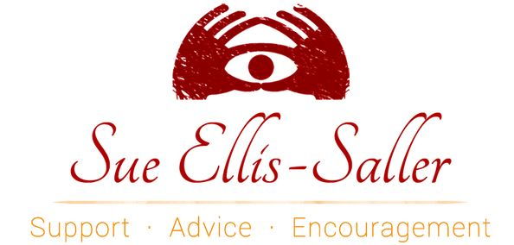

These questions will help you assess where you are in your business and what areas you’d like to improve on, reorganize, or work within in order to grow your business with more intention and flow.

GENERAL QUESTIONS about your biz...
How long have you been in business?

What do you do?
What do you feel are your greatest strengths?
What do you feel are your biggest challenges?
Do you feel like what you are doing is your calling?

Do you have a website?
How do you feel about your website, overall?
How do you feel about your business, overall?
How would you LIKE to feel about your business?
What are your priorities in business?
How much time do you work per week?
Do you allow yourself breaks and days off?

Do you have a brand? Logo, colors, fonts, and tone?

YOUR PEEPS/FLOCK/TRIBE
Do you know who your perfect client is?
Do you know the person you are speaking to so well that you can picture this person - and even get inside of this person's thought process to understand what he/she needs?
Do you know this person's gender, education level, interests, income level, location on the Earth, relationship status? Does the person you are speaking to have children? Is he or she facing a particular task or issue that you can help with?
Do you speak directly to this person in your blog and website?
Are you willing to turn someone away or refer the person to a better fit if you feel that you are not compatible?
Are you comfortable with "firing a client" if you feel that the relationship is not serving either of you - or one or the other of you?

YOUR BLOG:
Do you have a blog/vlog/podcast?
How often do you blog?
Do you have a blogging schedule?
Do you keep a list of potential topics to use when you are experiencing writer's block?

How often do you post new blog posts to your social media accounts?
What sorts of posts are you interested in sharing? Video? Audio? How tos?
Do you need help learning to create any of these?
What are your keywords?

TRAFFIC
How many visitors are you getting, per month, to your blog?
How are you driving traffic to your blog?
Do you do guest posts?
How many publications and other bloggers do you contact per month to inquire about guest posting?

NEWSLETTER AND MAILING LIST
Are you collecting email addresses from potential and/or past clients?

Do you have a lead magnet?
Who is your mail service provider?
How many people are on your list?
Do you have a newsletter?
How frequently do you send it out?
Do you know what your open rate is?

SOCIAL MEDIA
Which social media sites do you have a BUSINESS profile on? How many followers do you have per site?
Facebook:
Twitter:
YouTube:
Pinterest:
Instagram:
LinkedIn:
Any others? Please list them and your # of followers.
How often do you post?
Do you have a schedule?
What kind of posts do you create?
What kind of audience engagement do you have - how many people like, comment, or share your posts?

Are you using any sort of scheduling tool?

LOCAL MARKETING

Do you have business cards?
Do you have printed materials to share?
Where can you hang posters and pass out flyers?
Where would your perfect client shop and hang out? What events would they be attending?
What local magazines or papers could you advertise in?
Would you be willing to participate in local events? If so, which? Do you know the upcoming dates?
Would you be willing to participate in regional or international events? If so, which? Do you know the upcoming dates?

Are you a part of any local networking groups?

MONEY BLOCKS AND ISSUES
Do you feel like you have any money or abundance blocks?
Did/do you set your fees according to your experience, certification, and guidance?
Do you feel that your fees are too high or too low?
Do you feel that you are worthy of abundance and that the gifts you share are valuable?
Do you have problems with sending invoices for the full, advertised amount?
What percentage of the work you do is charity work, pro-bono, or freebies?
Are you satisfied with the amount that you earn in your business?
Do you believe that you can be successful?
What other measures of abundance do you recognize in your life?
Do you track - honestly and regularly - your business income?
Do you allow yourself to spend money on yourself?

OUR RELATIONSHIP/What you’d like to get from the group
What would you like to get from this group? How can I best serve YOU!?
How would you like to see your business grow during the time we spend together?
Is there anything specific that you would like to learn from me?
I think that is it for now!

--
With blessings and kind regards,
Sue

